ANNAMALAI UNIVERSITY
PART-I HINDI (COMMON FOR ALL UG DEGREE COURSES)
UNDER CBCS
(2022-2023)
FIRST SEMESTER – HINDI PAPER I – 22UHNDL11

Name of the course/subject: Hindi Semester: I
Name of the Paper: Hindi Paper- I Credits: 4 Hours of teaching: 90
Paper type: Language

Course Objectives
To appreciate Hindi Language and Literature
- To know the rules of Hindi grammar and its applications
- To develop effective communication skills
- To develop skills of translation and business correspondence
- To develop an in-depth knowledge of human life and to imbibe moral values through the writings of great authors

SYLLABUS AND BOOKS PRESCRIBED
I PROSE
(Gadya Nikash- Ed. Dr. Shaik Abdul Wahab, Sanrachna Prakashan, Allahabad)
- Yuvavastha – Pratapnarayan, Misra
- Lobh - Mahaveer Prasad, Dwivedi
- Sabhyata ka Rahasya - Premchand
- Bharat Ek Hai - Ramdhaari Singh Dinakar
- Krantikari Ki Katha - Harishankar Parsayee
II APPLIED GRAMMAR
Students are expected to know the various rules and applications of Hindi grammar
- Noun
- Pronoun
- Tenses
- Number (Vachan)
- Causal verb (Preranarthak kriya)
III LETTER WRITING
Personal and Business correspondence:
- Letter to Family members/Friend
- Placing orders books
- Letter of complaint
- Advertisement
- Business letters

IV FUNCTIONAL HINDI: ADMINISTRATIVE AND BUSINESS TERMINOLOGY
Technical Terminology: Words and phrases from English to Hindi and vice versa [Prescribed terminology enclosed]

V TRANSLATION PRACTICE
English to Hindi
(Passages from Anuvad Abhyas –Part III, D.B. Hindi Prachar Sabha, Chennai-17)

TEXT BOOK
- Gadya Nikash- Ed. Dr. Shaik Abdul Wahab, Sanrachna Prakashan, Allahabad

BOOKS FOR REFERENCE
- Shaikshik Vyakaran aur Vyavaharik Hindi- Dr. Krishna Kumar Goswami- Aalekh Prakashan, Delhi
- Hindi Vyakaran – Shastri & Apte, D.B.H Prachar Sabha, Chennai
- Pramanik Alekhan Aur Tippan- Prof. Viraj, Rajpal & Sons, Kashmere Gate, Delhi
- Glossary of Administrative Terminology, Ministry of HRD, New Delhi
- Anuvad Abhyas –Part III, D.B. Hindi Prachar Sabha, Chennai-17

COURSE OUTCOME
CO1. After having studied unit-1, the student will be able to know the origin and development of Hindi prose and appreciate Hindi language and literature.
CO2. After having studied unit-2, the student will be able to apply the rules of Hindi grammar for effective communication.
CO3. After having studied unit-3, the student will be able to write business correspondence effectively.
CO4. After having studied unit-4, the student will be able to use the business and administrative terminology in accuracy in meaning.
CO5. After having studied unit-5, the student will be able to translate the passages from English to Hindi efficiently.

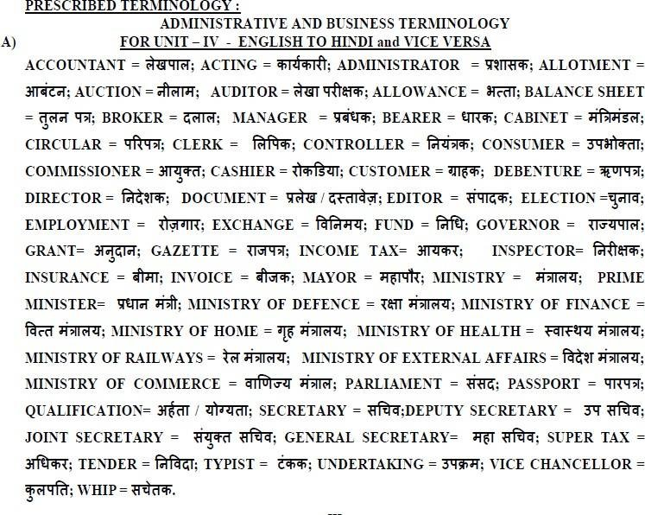
B)
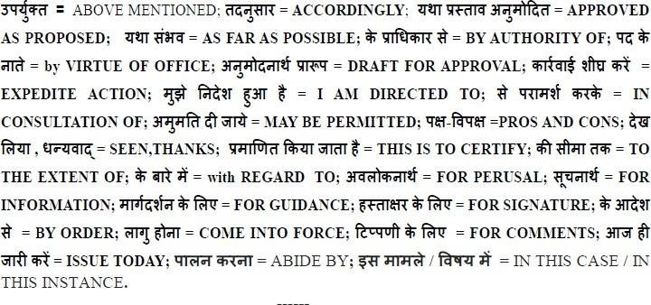

ANNAMALAI UNIVERSITY I YEAR B.A. / B.Sc./ B.Com/ BBA/BCA
FIRST SEMESTER – HINDI PAPER – I QUESTION PAPER PATTERN
Time: 3 hours Max marks: 75
SECTION A (10x2=20 marks)
Q.No.1 to Q.No.5 from Applied Grammar
Q.No.1 Number- 4 words
Q. No.2 Noun- 4 words

Q. No.3 Causal words- 4 words

Q. No.4 Spell check- 4 words

Q. No.5 Change of voice- 2 sentences

Q.No.6 to Q.No.10 - Short answer type questions from Prose

SECTION B (5x5 =25 marks)
Q.No.11 to Q.No. 13 Annotations from Prose (Either /Or Pattern)
Q.No.14 Technical words: English to Hindi and Hindi to English (5 out of 8 each)
Q.No.15 Technical Phrases: Hindi to English/ English to Hindi (Any 5 out of 8)

SECTION C (3x10=30 marks)
Answer any 3 out of 5. Q.No.20 is compulsory to answer
Q.No.16 Essay from Prose
Q.No.17 Essay from Prose
Q.No.18 Essay from Prose
Q.No.19 from Letter writing
Q.No.20 Translation of a passage from English to Hindi.

ANNAMALAI UNIVERSITY PART-I HINDI (COMMON FOR ALL UG DEGREE COURSES) UNDER CBCS
(2022-23)
SECOND SEMESTER – HINDI PAPER II - 22UHNDL21
Name of the course/subject: Hindi Semester: II
Name of the Paper: Hindi Paper- II Credits: 4 Hours of teaching: 90
Paper type: Language

Course Objectives
- To know the origin and development of different literary forms
- To understand and reflect on the social/cultural issues through the study of short stories and one act plays
- To develop effective communication skills
- To develop job oriented skills (Translation)
- To understand the develop an in-depth knowledge of human life and to imbibe moral values through the writings of great authors
SYLLABUS AND BOOKS PRESCRIBED
I ONE ACT PLAY
(Gadya Nikash, Ed. Shaik Abdul Wahab, Sanrachna Prakashan, Allahabad)
- Charumitra - Ramkumar Varma
- Das Hazar - Udayshankar Bhatt
- Raksha Bandhan - Harikrishna Premi

II SHORT- STORY (Non Detailed)
(Gadya Nikash, Ed. Shaik Abdul Wahab, Sanrachna Prakashan, Allahabad)
- Muktidhan - Premchand
- Raahi - Subhadrakumari Chouhan
- Biradari Baahar - Rajendra Yadav

III DIALOGUE WRITING
- Do Mitra (at friend house)
- Railway station mem
- Pita Aur Putra
- At the hotel
- pradhyapak Aur Vidyarthi
- Doctor Aur Rogi
- Bank Mein
IV APPLIED GRAMMAR
- Jodi Ke Shabd ,make the sentences
- Abstract Nouns (From Noun and Adjectives)
V TRANSLATION PRACTICE
Hindi to English
(Passages from Anuvad Abhyas – Part IV, D.B. Hindi Prachar Sabha, Chennai-17)

TEXT BOOK
- 1. Gadya Nikash, Ed. Shaik Abdul Wahab, Sanrachna Prakashan, Allahabad
BOOKS FOR REFERENCE
- Anuvad Abhyas – Part IV, D.B.Hindi Prachar Sabha, Chennai.
- Shaikshik Vyakaran aur Vyavaharik Hindi, Dr. Krishna Kumar Goswami, Aalekh Prakashan, Delhi.
- Bolchal ki Hindi, Dr. Susheela Gupta, Lokbharathi Prakashan, Allahabad.
- Hindi Vyakaran: Sastri & Apte, D.B.H.P. Sabha, Chennai.

COURSE OUTCOME
CO1. After having studied unit-1, the student will be able to understand the cultural traditions, moral values and social issues of life in a better way.
CO2. After having studied unit-2, the student will be able to cultivate the habit of critical thinking and cherish life.
CO3. After having studied unit-3, the student will be able to communicate effectively in Hindi in their day to day life.
CO4. After having studied unit-4, the student will be able to use Hindi as a medium of communication by applying the rules of Hindi grammar.
CO5. After having studied unit-5, the student will be able to do translation and get equipped with a job-oriented skill.

ANNAMALAI UNIVERSITYI YEAR B.A. / B.Sc./ B.Com/ BBA/BCA
SECOND SEMESTER – HINDI PAPER – II QUESTION PAPER PATTERN

Time: 3 hours Max marks: 75

SECTION A (10x2=20 marks)
1-8 Short answer type questions
Q.No: 1 – 4 from One Act Play
Q.No: 5 - 8 from Short Story
Q.No: 9 from Jodi ke Shabd (Meaning & Use In Sentence - 2)
Q.No: 10 Form Abstract Noun (4)

SECTION B (5x5=25 marks)
Q.No.11 to Q.No. 13 Annotations from One Act Play (Either /Or Pattern)
Q.No. 14 & Q.No. 15 Dialogue writing (Either /Or Pattern)

SECTION C (3x10=30 marks)
Answer Any 3 Out Of 5. Q.No.20 is compulsory to answer.
Q.No. 16 Essay from One Act Play
Q.No. 17 Character sketch from One Act Play
Q.No. 18 Essay from Short Story
Q.No. 19 Character sketch from Short Story
Q.No. 20 Translation of a Passage from Hindi to English

ANNAMALAI UNIVERSITY,
PART-I HINDI (Common for all UG Degree Courses)UNDER CBCS
(2022-2023)
(For B.A. / B.Sc.)
UNDER CBCS
(with effect from 2022-2023)
THIRD SEMESTER – HINDI PAPER – III - 22UHNDL31
Name of the course/subject: Hindi Semester: III
Name of the Paper: Hindi Paper- III Credits: 4 Hours of teaching: 90
Paper type: Language
………………………………………………………………………………………………
Course Objectives
- To appreciate the Ancient and medieval Hindi poetry
- To understand the culture of our nation and to facilitate national integration
- To cultivate the habit of critical thinking and analysis through the study of drama
- To enhance effective communication skills
- To create an awareness of the distinct features of each era of ancient Hindi literature.

SYLLABUS AND BOOKS PRESCRIBED
I ANCIENT & MEDIEVAL POETRY
(Sanrachna Kavya Sanchayan, Sanrachna Prakashan,Allahabad)
- Kabir - Dohe
- Surdas - Pad
- Tulsidas- Shree Seetha-Ram Samvaad
- Rahim - Dohe
- Bihari - Dohe
- 6.Thiruvalluvar - Kural

II DRAMA
‘YUGE YUGE KRANTHI’ by Vishnu Prabhakar, Rajpal & Sons, Kashmere Gate, Delhi.

III MUHAVARE AUR LOKOKTIYAN
Meanings only (Prescribed Idioms and Proverbs enclosed)

IV LANGUAGE & APPLIED GRAMMAR
Ekkartha sahbda (Pariyayvachi shabd)
- Antonyms (Vilom shabd)
- Words with different meanings (Bhinn arth wale shabd)
- One word Substitution (Anek shabdon ke liye ek shabd)
- Tense – (Bhoothkaal, Varthamankaal, Bhavishyathkaal)

V HISTORY OF HINDI LITERATURE
General information about the poets belonging to the first three periods (Aadhikaal, Bhakthikaal and Reethikaal)
1.Chand Bardai 2.Vidyapathi 3Aamir khusaro 4.Keshav Das 5.Guru koraknath
TEXT BOOKS
- Sanrachna Kavya Sanchayan, Sanrachna Prakashan, Allahabad
- ‘Yuge Yuge Kranthi’ by Vishnu Prabhakar, Rajpal & Sons, Kashmere Gate, Delhi

BOOKS FOR REFERENCE
- Hindi Sahitya Ka Itihas, Ramchandra Shukla, Karvi Prakashan, Jaipur
- Hindi Sahitya Ka Ithihas, Dr. Nagendra,National Publishing House, New Delhi.
- Vyavaharik Hindi Vyakaran by Dr.Hardev Bahri , Lokbharathi Prakashan, Allahabad.
- Hindi Ke Prachin Prathinidhi Kavi,Dwarika Prasad Saxena,Vinod Putak Mandir,Agra.
- Hindi Rooprachana Part-2,Acharya Jayendra Trivedi,Lok Bharathi Prakashan,Illahabad-2.

COURSE OUTCOME
CO1. After having studied unit-1, the student will be able to understand human life in depth and become good citizens with moral values through the writings of great poets.
CO2. After having studied unit-2, the student will be able to cultivate the habit of critical thinking and cherish life through study of literature.
CO3. After having studied unit-3 and 4, the student will be able to communicate effectively in Hindi in their daily life.
CO4. After having studied unit-5, the student will be able to understand the social background, the trends, the famous poets and their works during the first three periods of the history of Hindi literature.

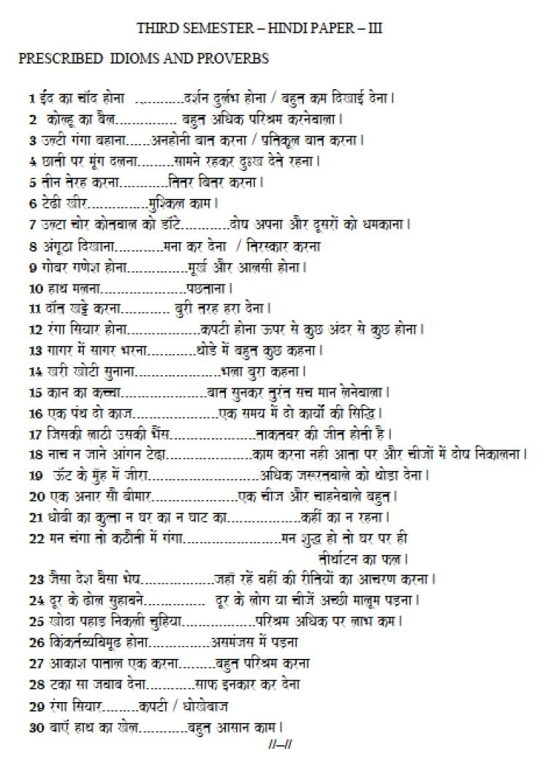

ANNAMALAI UNIVERSITY, SECOND YEAR B.A. / B.SC
THIRD SEMESTER – HINDI PAPER – III QUESTION PAPER PATTERN
Time: 3 hours Max marks: 75
SECTION A (10 x 2 = 20 marks)
1-10 Short answer type questions
Q.No 1 to 4 from Poetry
Q.No 5 to 8 from Drama
Q.No 9 & 10 from History of Hindi Literature

SECTION B (5x5 = 25 marks)
Q. No. 11 & 12 Annotations from Poetry (Either /or pattern)
Q. No. 13 & 14 Annotations from Drama (Either /or pattern) Q.No. 15 Meanings of idioms & proverbs (5 out of 7)

SECTION C (3x10 = 30 marks)
Answer any THREE out of FIVE.Q.No.20 is compulsory to answer.
Q.No.16 Essay from Poetry
Q.No.17 Essay from Poetry
Q.No.18 Essay /or Character sketch from Drama
Q.No.19 Short notes on 2 prescribed Authors out of 3 (History of Hindi Literature)
Q.No.20 Applied grammar
1. Ekarthi sahbda (4 words)
- Antonyms (4 words)
- Words with different meanings (4 words)
- One word substitution (4)
- Tense – Change as directed (2)

ANNAMALAI UNIVERSITY
PART-I HINDI
(For B.A. / B.Sc.)
UNDER CBCS
(with effect from 2022-2023)
FOURTH SEMESTER – HINDI PAPER – IV - 22UHNDL41
Name of the course/subject: Hindi Semester: IV
Name of the Paper: Hindi Paper- IV Credits: 4 Hours of Teaching: 90
Paper type: Language

Course Objectives
- To appreciate Modern Hindi Poetry
- To enhance critical thinking, imagination, self and social awareness through the study of novels and poetry
- To improve communication skills and fluency in Hindi
- To learn the office procedures and official correspondence
- To create an awareness of the distinct features of modern Hindi literature through the writings of great authors
SYLLABUS AND BOOKS PRESCRIBED
I MODERN POETRY
(Sanrachna Kavya Sanchayan, , Sanrachna Prakashan, Allahabad)

- Yashoda – Uddhav Samvaad – Ayodhya Singh Upadhyay Harioudh
- Kaisa ho Apna Sansar - Mythilisharan Gupta
- Chinda ka Udbodhan - Jai Shankar Prasad
4 Sukh -Dukh - Sumithranandan Panth
- Mera Jeevan - Subhadra Kumari Chouhan
- Toota Pahiya - Dharmaveer Bharathi
II NOVEL (NON-DETAILED STUDY)
‘DAUD’ by Mamta Kaliya, Vaani Prakashan, New Delhi.
III APPLIED GRAMMAR
- Case endings (Karak)
Usage of ne, ka, ke, ki, ko, se, mei, par
- Correction of Sentences (Shuddh kijiye)
IV FUNCTIONAL HINDI -OFFICIAL CORRESPONDENCE
[Definitions and context of usage only]
- Circular
- Office Memorandum
- Notification
- Demi Official Letter
V HISTORY OF HINDI LITERATURE - ADHUNIK KAAL
General information about the prescribed poets / writers from Modern Period 1. Nagarjun2.. Mohan rakesh3.. Dharmavir bharti 4.Dhoomil 5. Krishna Sobthi.
TEXT BOOKS
- Sanrachna Kavya Sanchayan, Sanrachna Prakashan, Allahabad.
- Daud, Mamta Kaliya, Vaani Prakashan, New Delhi.
- Hindi Sahitya Ka Ithihas, Dr. Nagendra, National Publishing House, New Delhi

BOOKS FOR REFERENCE
- Karyalay Alekhan Aur Tippan, Karnatak Mahila Hindi Sewa Samiti, Bengaluru.
- 2.Vyavaharik Hindi Vyakaran by Dr.Hardev Bahri , Lokbharathi Prakashan, Allahabad.
- 3...Hindi Ke Prachin Prathinidhi Kavi,Dwarika Prasad Saxena,Vinod Putak Mandir,Agra.
- 4.Hindi Rooprachana Part-2,Acharya Jayendra Trivedi,Lok Bharathi Prakashan,Illahabad-2

COURSE OUTCOME
CO1. After having studied unit-1, the student will be able to understand the various trends and styles of the poets of modern Hindi literature.
CO2. After having studied unit-2, the student will be able to cultivate the habit of critical thinking and cherish life.
CO3. After having studied unit-3, the student will be able to communicate effectively in Hindi in their day to day life.
CO4. After having studied unit-4, the student will be able to do official drafting efficiently.
CO5. After having studied unit-5, the student will be able to understand the origin and development of modern Hindi literature and the life history and works of the famous representative writers.

ANNAMALAI UNIVERSITY,
SECOND YEAR B.A. / B.SC
FOURTH SEMESTER – HINDI PAPER – IV
QUESTION PAPER PATTERN
Time: 3 hours Max marks: 75

SECTION A (10x2=20 marks)
10 Short Answer Type Questions
Q.No. 1 to 4 from Poetry
Q.No. 5 to 8 from Novel
Q.No. 9 & 10 from definitions of official letters

SECTION B (5x5 = 25 marks)
Q. No. 11 to 14 Annotations from Poetry (Either or pattern)
Q. No. 15 Match the following - Prescribed Authors and their Works
(From modern poetry and Adhunikkaal)

SECTION C (3x10 = 30 marks)
Answer any THREE out of FIVE. Q.No.20 is compulsory to answer.
Q.No.16 Essay from Poetry
Q.No.17 Essay from Poetry
Q.No.18 Essay from Novel
Q.No.19 Short notes on 2 prescribed Authors out of 3 (Adhunik Kaal)
Q.No.20 Applied Grammar 1. Fill in the blanks using case endings (5)
2. Correction of Sentences (5)

