GUIDELINES

FOR PREPARATION AND SUBMISSION

OF Ph.D. THESIS


FACULTY OF ENGINEERING & TECHNOLOGY ANNAMALAI UNIVERSITY
ANNAMALAINAGAR – 608 002
April, 2016
ARRANGEMENT OF PARTS OF A THESIS

- COVER PAGE

- INSIDE COVER PAGE

- CERTIFICATE

- DECLARATION BY RESEARCH SCHOLAR

- ACKNOWLEDGEMENTS

- ABSTRACT

- TABLE OF CONTENTS

- LIST OF TABLES

- LIST OF FIGURES

- ABBREVIATIONS (if any)

- NOTATION (if any)

- CHAPTERS

- APPENDICES

- REFERENCES

- LIST OF PUBLICATIONS

2

Ph.D. THESIS FORMAT GUIDELINES

FOR

FACULTY OF ENGINEERING AND TECHNOLOGY

Ph.D. thesis format is designed to provide Ph.D. scholar with the formatting requirements for their thesis reports. It covers structure, layout, form, and style.

1. GENERAL:

The guidelines for the preparation of Ph.D. thesis are outlined below. In general, the Ph.D. thesis shall have, in an organized fashion, an account of original research work of the Ph.D. scholar leading to the discovery of new facts or techniques or correlation of facts already known (analytical, experimental, hardware oriented etc.) and demonstrating a quality so as to make a definite contribution to the advancement of knowledge and the Ph.D. scholar's ability to undertake sustained research and present the findings in an appropriate manner with actual accomplishments of the work plainly stated and honestly appraised.

2. ARRANGEMENT OF CONTENTS:

The sequence in which the Ph.D. thesis arranged and bound shall be as follows:

- Cover page: The cover page includes the title, author, degree (“A Thesis submitted by SCHOLAR NAME for the award of the degree of DOCTOR OF PHILOSOPHY”), Department, university and month and year. A specimen copy of the cover page is given in Annexure 1. Cover page should be presented in the black & white form.

- Certificate Page: The Bonafide Certificate shall be in double line spacing using Font Style Times New Roman and Font Size 12, as per the format given in Annexure 2. The certificate shall carry the Guide Name, Academic Designation, Department and Full Address of the institution where the Guide has guided the student, body of Bonafide and shall be followed by the Guide signature at right justified. In case main and co-guides are present, include Co-Guide signature as given in Annexure 2.

- Declaration by Research Scholar: The Declaration by candidate shall be in double line spacing using Font Style Times New Roman and Font Size 12, as per the format given in Annexure 3.

- Acknowledgments page: This should not exceed two pages. Acknowledgment shall be in double line spacing using Font Style Times New Roman and Font Size 12.

3

  - Abstract: A concise summary of the essential information of the work being presented, namely of the study’s scope, purpose and results. The reference-free double line spaced abstract should not exceed two pages (not more than 600 words) and should contain not more than 6 key words. Refer Annexure 4.

- Table of Contents: It includes all the subsections of each chapter and the list of appendices (if applicable) and page numbers. The table of contents should list all materials following it as well as any material which precedes it. The title page and Bonafide Certificate will not find a place among the items listed in the Table of Contents but the page numbers of which are in lower case Roman letters. One and a half (1.5) spacing should be adopted for typing the matter under this head. A specimen copy of the Table of Contents is given in Annexure 5.

- List of Tables: The list should use exactly the same captions as they appear above the tables in the text. One and a half spacing should be adopted for typing the matter under this head. It includes table number, caption, and the page number. Refer Annexure 6.

- List of Figures: The list should use exactly the same captions as they appear below the figures in the text. One and a half spacing should be adopted for typing the matter under this head. Its include figure number, caption, and the page number. Refer Annexure 7.

- List of Abbreviations: Refer Annexure 8.

- List of Notations: Refer Annexure 9.

- Thesis Text: the layout is described in the next section. The table and figures shall be introduced in the appropriate places. Refer Annexure 10.

- Appendices – Appendices are provided to give supplementary information, which is included in the main text may serve as a distraction and cloud the central theme.

- Appendices should be numbered using Arabic numerals, e.g. Appendix 1, Appendix
2, etc.

- Appendices, Tables and References appearing in appendices should be numbered
and referred to an appropriate places just as in the case of chapters.

- Appendices shall carry the title of the work reported and the same title shall be made
in the contents page also.

- List of References: The listing of references should be typed one space below the heading “REFERENCES” in alphabetical order in single spacing left – justified. All reference should be listed in the alphabetical order of the last name of first author. The References shall be in single line spacing using Font Style Times New Roman and Font Size 12, as per the format in Annexure 11. Between the references use one line space gap. References
4
need to be cited inside the Chapters using bold font last name of first author followed by the year with in parenthesis. If two same authors published in the same year, it shall be referred by the year with alphabets. Refer Annexure 10.

- THESIS FRAMEWORK

This information is offered as a general guideline. Ph.D. scholars should always consult
their advisor for additional guidelines.

  - Introduction: background; statement of the problem; definition of terms; purpose of the study; theoretical basis; contributions of the study; organization of the remainder of the study.
  - Literature Review: chronological, categorical or related theoretical viewpoints related to topic. At the end of literature review, the Scope and objectives need to be presented.
  - Proposed Solution/Methodology: research design or approach (quantitative, qualitative or algorithmic); population and / or sample; collection and tabulation of data; and data analysis procedures.
  - Solution Validation, Analysis of the Data, Results and Discussion: presentation and discussion of the findings, including limitations.
  - Conclusions and Recommendations: summarizes the entire research effort; addresses the initial purpose of the study (stated in the introduction); stresses the importance of the work accomplished; leaves a final impression on the reader. It can also include suggestions for further work.
  - Bibliography/References: references should acknowledge any work done by someone other than the author. The reference should also include work performed by the author if presented or published at an earlier date.
  - Appendices: material too detailed or lengthy for inclusion in the body of the study (e.g. questionnaires, maps). Appendices may also contain information that might clarify the thesis but is routine in nature or indirectly related to the thesis. Raw data and examples of calculation could be incorporated.

- SPECIFICATIONS FOR THESIS FORMAT

4.1 Preparation of Manuscript and Copies

The thesis needs to be prepared using a standard text processing software and must be
printed in black colour text (colour for images, if necessary) using a laser printer or letter
quality printer in standard typeface (Times New Roman).
The thesis must be printed or photocopied on both sides of A4 size white paper. All copies of thesis pages must be clear, sharp and even, with uniform size and uniformly spaced characters, lines and margins on every page of good quality white paper of 80gsm.Thesis should be free from typographical errors.

5

4.2 Paper: Use high-quality acid-free A4-size paper.

4.3 Page Dimensions and Margin:

The dimensions of the thesis should be 290mm × 205mm. Standard A4 size (297mm× 210mm) paper may be used for preparing the copies.

The Report / Thesis (at the time of submission) should have the following page margins:

Top edge: 25.4 mm (1.0 in)

Bottom edge:17 mm (0.67 in)

Left side:33.02 mm (1.3 in)

Right side:31.7 mm (1.25 in)

Please note that the bottom of the page numbers should be 17.0 mm above the bottom edge of the numbered pages.

Tables and figures should conform to the margin specifications. Large size figures should be photographically or otherwise reduced to the appropriate size before insertion.

4.3 Size

In disciplines where section numbering is normally used, the following guidelines apply:

- Chapter title: 14pt size, bold.

- Main Section Headings: can be numbered as chapter-number. Section-number (e.g., 3.2 for chapter 3, section 2) in 12pt size, bold.

- Second Headings: can be numbered as x.y.z (e.g., 3.2.4 for chapter 3, section 2, and sub section 4) in 12 pt size, bold. Avoid numbering beyond.

- First Subheadings: preferably unnumbered, 12 pt, italics, under lined

4.4 Page Numbering

The page numbering starts from acknowledgement to the first Chapter and should be printed using small roman letters i.e. i, ii, iii, iv, v, .. . Refer Annexure 5.

The page numbering starts from first Chapter onwards and it should be printed using Arabic numerals i.e. 1, 2, 3, 4, 5.

The page numbers should be located at the bottom centre of each page, 17mm (2/3”) from the bottom edge using normal print

Beginning with the first page of the text in the thesis (chapter 1), all pages should be numbered consecutively and consistently in Arabic numerals through the appendices.
Page numbers prior to Chapter 1 should be in lower case Roman numerals.

The title page is considered to be page (i) but the number is not printed. Certificate and Acknowledgement are considered to be pages (ii) and ( iii) but the number is not printed

All page numbers should be placed without punctuation in the bottom centre of the page.

6
4.5 Line Spacing

Use Single Line Spacing

- In footnotes and endnotes for text, long quotations

- In explanatory notes for tables captions and figure captions.

- In text corresponding to bullets, listings, and quotations in the main body of the thesis.
- All individual references need to be typed with single line space but in between
references require at least one line space gap
- between the paragraphs. All paragraphs in the thesis should be left justified completely, from the first line to the last line.
- Last line of a section / sub-section and the title of the next section/ sub-section.
- Chapter title and first sentence of a chapter.

Use Double Line Spacing between the regular texts in all Chapters.

Justification: The text should be fully justified. Hyphenation should be avoided as far as possible. Text corresponding to bullets, and listings should be indented. Quotations from other research work must be indented on the left and the right. If they are longer than two lines. Shorter quotations can be included as a part of the text.

Widows & Orphans: At the bottom of a page, a paragraph should have atleast two lines. Similarly at the top of a page, a paragraph should end with atleast two lines

4.6 Tables

Sample tables are provided in Annexure 12. All tables should have sharp lines, drawn in black ink, to separate row/ column as and when necessary.

Tables should follow immediately after they are reflected to for the first time in the text. Splitting of paragraphs, for including tables on the page, should be avoided. Provide single line space on the top and the bottom of all tables to separate them from the regular text, wherever applicable. See Annexure 12 for an example.
The last line of the title of any table should be 10 mm or 15 mm above the top most horizontal line of the table, and the title should be cantered with respect to the table. The title must be in the same font as the regular text and should be single-spaced. The title format is given below:

Table<blank><chapter number><dot><serial number><left indent><table title>

Example: Table 2.1 Properties of Concrete

Percentage of samples with discretized priority vector rankings different from original priority vector ranking. Results of the simulation experiment. The contents of the table will be within the surrounding double line (which indicates the top-most, left-most, right-most,

7

and bottom-most boundaries of the table). Wherever a table exceeds one page present the full title of the table on the first page and in the following pages provide the table number and state “(contd.)” after it.
Example: (notice the left justification)

Table 5.7 (contd.)

Wherever explanatory notes are used for clarifying any information presented inside the tables. Print them after leaving a single space immediately below the tables. All tables in landscape format must be placed such that their top portions are near the binding of the thesis and their bottom portions near the outer edge.

If tables are of only half a page or less, they may appear on the same page as text but separated above and below by triple line spacing. Font size for text should be the same as for the general text.

4.7 Figures

Sample figures are given in Annexure 12. All photos, drawings, and graphs should be in black /colour with adequate contrast. All photos, drawings, and graphs should follow immediately after it is referred to for the first time in the text. Splitting of paragraphs, for including figures on the page, should be avoided. Provide single line space on the top and bottom of all figures to separate them from the regular text, wherever applicable. See Annexure 12 for an example.

The first line of the title for photos, drawings and graphs should be between 10 mm and 15
- below the bottom and they should be cantered with respect to the figure. The title must
be in the same font as the regular text and should be single-spaced. The titled format is
given below:
Fig.<blank><chapter number><dot><serial number><left indent><figure title>.

Example: Fig. 6.2 Bending Moment Diagram

Wherever a figure exceeds one page ( as in the case of large flow charts for computer programs ) present the full title of the figure on the first page and in the following pages provided in the figure number and state”(contd.)” after it. Example: (notice the left justification)

Fig. 4.23 (Contd.)

When there are many plots in a single graph or figure, the lettering, labelling or numbering of each plot for its identification should be of a size such that even after size reduction in the thesis, the identification should be clearly legible. All figures in landscape format must

8

be placed such that their top portion are near the binding of the thesis and their bottom portions near the outer edge.

If figures are of only half a page or less, they may appear on the same page as text but separated above and below by triple line spacing. Font size for text should be the same as for the general text.

4.8 Equations

All equations typed using equation editor wherever possible, on the same paper used to type the text and conform to the specifications outlined earlier. It should be inserted as close to the textual reference as possible.

All equations should be numbered sequentially either throughout the thesis or chapter-wise using Arabic numerals. They are referred to in the body of the text capitalizing the first letter of the word and number, as for instance, Equation (3.3), or Equation (4.16), etc. Font size for text should be the same as for the general text. All variables should be typed in italics including superscripts and subscripts but not the symbols and numbers.
$Δ_{i}=Δ_{i−1}+θ_{i−1}(x_{i}−x_{i−1})−\frac{1}{2}φ_{i−1}(x_{i}−x_{i−1})^{2}$ (4.1) $φ_{i}=f(M_{i},P)$ (4.2)
$P_{\text{uR}}=C_{c}+C_{F}={\text{af}}_{\text{ck}}\text{bD}+\sum_{i=1}^{n}{\left(f_{\text{fi}}−f_{\text{ci}}\right)}A_{\text{fi}}$ (4.3)
4.9 Photos

Use colour photos only if they are necessary. Remember that the thesis may have to be photocopied. In case colour photos are used, all copies of the thesis must contain only colour photos. Photos should be printed on A4 size paper. Each photo should be numbered and referred inside the text atleast once as figure.

4.10 Drawings

Drawing which are larger than A4 size are not encouraged, if larger drawing are absolutely necessary they may be suitably folded to A4 size in the thesis. (Take care to reduce the sizes when A5 form of the thesis is prepared). Each drawing should be numbered and referred to as figure. Drawing titles should be similar to those provided for figures.

Good quality Line Drawings/figures must be drawn using standard software that provides vector rather than bit-map graphics. Figures must be scalable. Images, Photographs, etc. must be scanned in resolution exceeding 200dpi.

9

4.11 Footnotes

In presenting footnotes and reference use a consistent form acceptable in your discipline.

See Annexure 10 for a sample.

4.12 Punctuation

- Insert a comma wherever there would be a slight pause between words or phrases in the spoken sentence

- Insert a semicolon between two parts of a sentence; the proviso is that both parts must be able to stand alone as separate sentences.

- Use a colon to introduce an explanation or an example of something: here is an example. If there are several simple explanations or examples, separate them with commas; otherwise, use semicolons.

- Avoid excessive use of parentheses ( ). Use them to make an aside (an extra remark) only if commas could be confusing. Never use parentheses within parentheses: find another way of saying it.

- Use brackets [ ] for material inserted into a quotation and ellipsis (three dots) for material omitted: According to Smith (1999), "few such [descriptive] studies were done… before 1950."

- Use dashes--two hyphens with no spaces anywhere--for emphatic asides.

- Use one or two spaces after a period, colon, or semicolon. Note, though, that Web browsers delete more than one space unless you make them non-breaking spaces.

- Use double quotation marks (") for speech and verbatim quotations.

- If a quotation is long, type it as an indented block of text without quotation marks, as shown in this example: According to Smith (1982)...

The "newbie effect" disappeared when behaviours were studied in this manner. Examples of methods included indirect observation, self-reports, and retrospective questionnaires. (p. 276)

- Use double quotation marks the first time you introduce a newly coined or slang term; do not use quotation marks thereafter.

- Don't use "smart quotes" (66 and 99), because they create problems when translated into Web documents.

- Use single quotation marks (') for quotes within quotes.

- Use the apostrophe (') to denote possession: an athlete's responses, two athletes' responses. But note that its = of it, whereas it's = it is.

10
- Put commas, semicolons, colons, and periods outside closing quotation marks: "this",

for example, but not "this," or "this." Exception: "If the quotation ends in a complete sentence, the period is part of the quote and should therefore go inside the quotation marks, like this." [APA: all punctuation goes within the quotation marks.]

- Use of and/or instead of or is acceptable when you want to emphasize either or both.

- The forward slash (/) can be used instead of or in sentences that are already replete with ands and/or ors.

- Use Title Case (initial upper-case letters for words of four or more letters) in:

  - the title and subheadings of your article;

  - titles of journals;

  - titles of books or articles in the text, but not in the reference list;

  - proper nouns, including trade names (Wilks's lambda, Aspro, the Web and a Web site, but not in a website);

  - names of experiments (the Slump Cone Test);

  - nouns followed by numbers (on Day 2, in Group B) but not in the control group;

  - names of institutional departments (Department of Sport Science, University of Wherever), but not of disciplines (a department of sport science);

  - References to sections of the article (in the Methods section; see Results; in Figure 1; in Table 2; see Annexure 4; in Chapter 4).

5. BINDING

Thesis should be bound using flexible cover of thick white art paper. The cover should be printed in black colour and the text for printing should be identical as prescribed for the cover page. Pages are secured with glue and prepared using standard hard bound thesis Binding whenever practicable diagrams, maps, illustrations, computer printouts, published papers and tables should have a binding margin of at least 40 mm (1.5'') and should, if possible, be bound into the thesis near the appropriate text.

6. PUBLICATIONS BY THE CANDIDATE

Articles, technical notes etc. On the topic of the thesis published by the candidate may be separately listed after the literature cited (Annexure 13). This may also be included in the content. The candidates may also included reprints of his/her publications after the literature citation.

11
- SYNOPSIS GUIDELINES

- 1 GENERAL

The synopsis is to be considered as a detailed summary of the work with important results highlighting the original contributions in the thesis to be submitted. It should give an outline of the thesis. The review of earlier work is to be minimized with just enough to highlight the contributions in the research work to be reported in the thesis. It is expected that at the time of submission of the synopsis no work is yet to be completed except writing the thesis and all other academic requirements such as course work, comprehensive examinations and the suggestions and directions given by members of the Doctoral Committee have been fulfilled.Ph.D. synopsis format is designed to provide Ph.D. scholar with the formatting requirements. The cover structure, layout, form, and style are given in Ph.D. Thesis guidelines. Total number of pages restricted to 20 including cover page.

7.2. SIZE OF SYNOPSIS

The size of synopsis should be 20 pages of 1.5 spacing on A4 size good quality white paper preferably not lower than 80 gsm.

7.3. LAY OUT OF SYNOPSIS

- Cover Page (Refer ANNEXURE 14)

- Table of Contents

- Body of the Synopsis

Motivation and Problem statement

Brief survey of earlier work

Overview of the thesis
Major contributions (if required with results/ graphs/photographs)

Conclusions

- List of References (pointed references only in the body of the synopsis)

- List of Publications (from the Ph.D. work)

7.4. TYPING INSTRUCTIONS

Similar to Ph.D. guidelines

7.5. BINDING SPECIFICATIONS

Copies of the synopsis should be sewn and bound using flexible cover of thick white art paper. The cover should be printed in black letters and the text for printing should be identical to what has been prescribed for Ph.D. cover page.

12

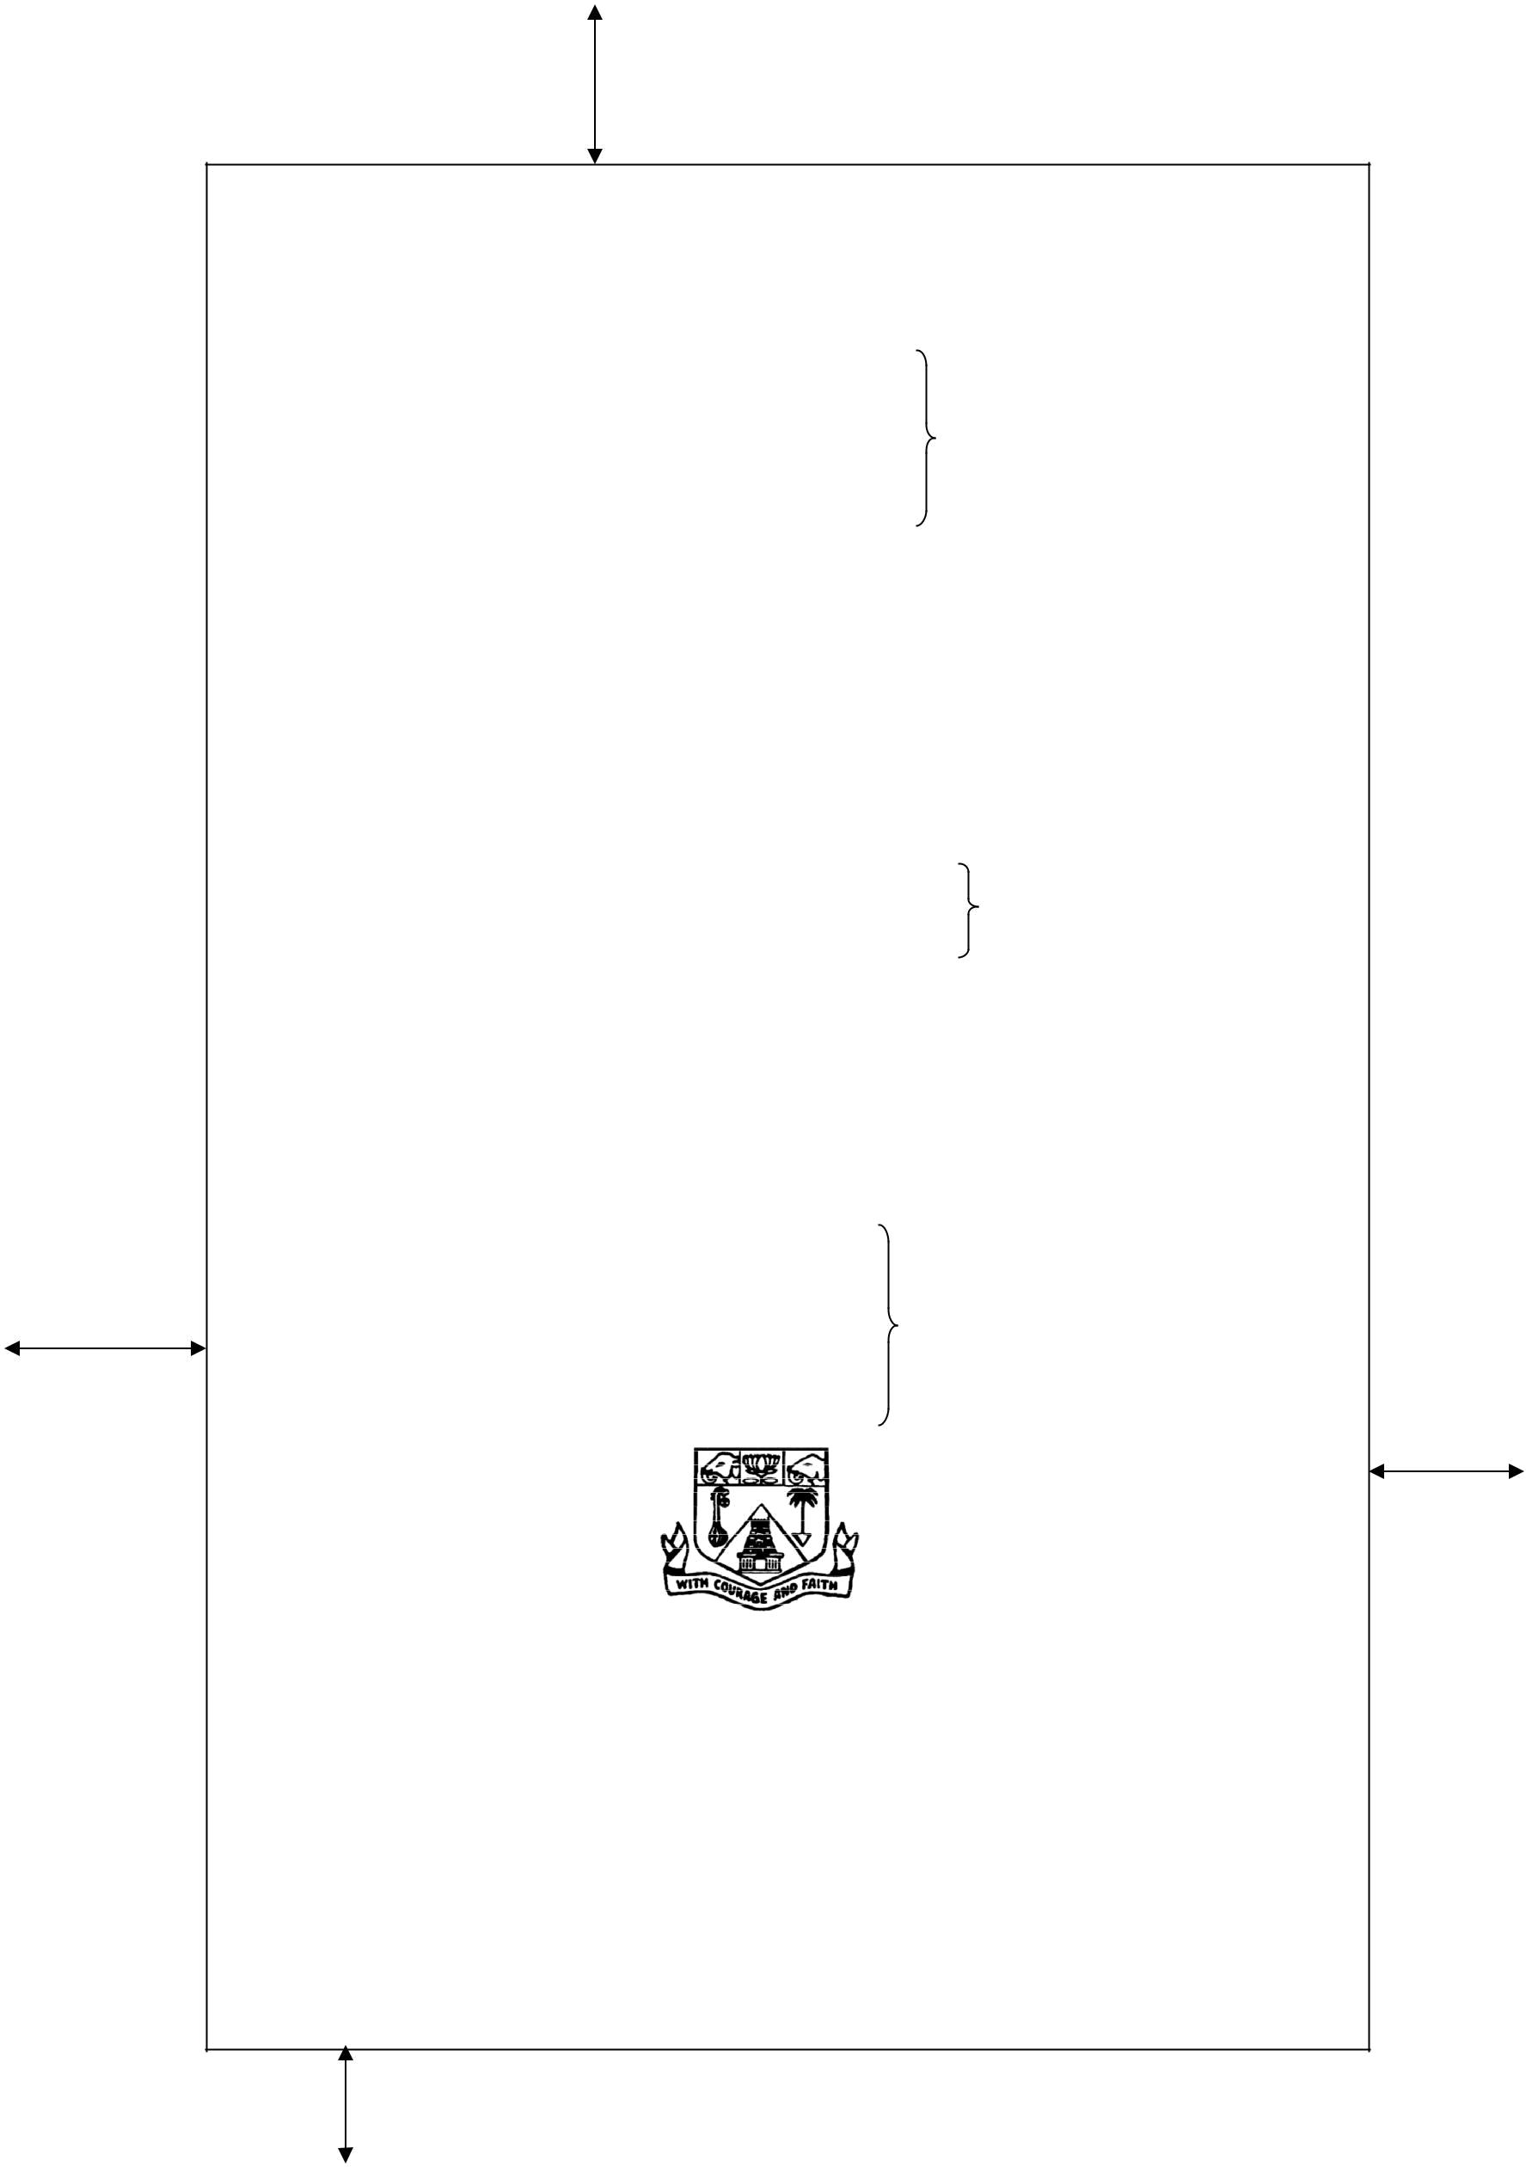
25.4 mm

ANNEXURE 1

A STUDY OF COMBINED BENDING AND AXIAL LOAD IN
CONCRETE COLUMNS REINFORCED INTERNALLY WITH
NON-METALLIC REINFORCEMENTS

< 14 pt; Times New Roman; no space in between lines; Bold>

< 3 line spaces each 12Pts >

  - Thesis

- 13 pt; Times New Roman; Bold>

<1 line space 12Pts >
Submitted by

< 12 pt; Times New Roman; italics>

<1 line space 12Pts >
A.AJITHKUMAR

  - 14 pt; Times New Roman, Bold>

Roll No. 1331050017

- 12 pt; Times New Roman; Bold >

<2 line spaces each 12Pts >

In partial fulfilment for the requirements of the award of the degree of

< 12 pt; Times New Roman; italics>

DOCTOR OF PHILOSOPHY
IN
STRUCTURAL ENGINEERING

- 14 pt; Times New Roman; Bold>

  - 5 line spaces each 12Pts >

33.02 mm
31.7 mm

< 3.5 cm ×3.5 cm Image > <300 dpi>

DEPARTMENT OF CIVIL AND STRUCTURAL ENGINEERING
FACULTY OF ENGINEERING AND TECHNOLOGY
ANNAMALAI UNIVERSITY
ANNAMALAINAGAR - 608 002

TAMIL NADU, INDIA
MAY 2016

< 14 pt; Times New Roman; no space in between lines; Bold>

17 mm

ANNEXURE 2



ANNAMALAI UNIVERSITY

< 14 pt; Times New Roman; Bold>

RESEARCH SUPERVISOR’S NAME

Designation

Department of

Faculty of

Annamalai University

Annamalainagar -608 002

Tamil Nadu

India

< 12 pt; Times New Roman>

CERTIFICATE

< 14 pt; Times New Roman; Bold>

This is to certify that the thesis entitled “THESIS TITLE <Bold, 12 Pts, Time New Roman>” is a bonafide work of Mr./Ms. Scholar Name <Bold, 12 Pts, Time New Roman> (Roll No. __________ ), Ph.D. Scholar, Department of……………….., Faculty of Engineering and Technology, Annamalai University who carried out research under my supervision for the award of the Degree of DOCTOR OF PHILOSOPHY. Certified further, that to the best of my knowledge this thesis has not previously formed the basis for the award of any Degree, Diploma, Associateship, Fellowship or other similar title to the candidate.
<12Pt ; Times New Roman; Double Line Space>

Signature of the Co- Research Supervisor

Signature of the Research

Supervisor

Station:

Date:

ANNEXURE 3


ANNAMALAI UNIVERSITY
Annamalainagar

- 14 pt; Times New Roman; bold>

(This format shall be used for declaration by the candidate in submission of thesis)

DECLARATION

< 14 pt; Times New Roman; Bold>

I, _______________________________________(Roll No. ___________) Research Scholar in the Department of __________________ declare that the work embodied in this Ph.D. thesis entitled “THESIS TITLE <Bold, 12 Pts, Time New Roman>”is a result of my own bonafide work carried out with my personal effort and submitted by me under the supervision of _________________at Annamalai University, Annamalainagar (and the Co-Supervision of ______________at ________ wherever applicable). The contents of this thesis have not formed the basis for the award of any Degree/Diploma/ Fellowship/ Titles in this University or any other University or similar Institutions of Higher Learning.
I declare that I have faithfully acknowledge and given credit and referred to the researchers wherever their works have been cited in the body of the thesis. I further declare that I have not willfully copied some other’s data/ work/ results etc. reported in the journals, magazines, books, reports, dissertations, theses, internet etc. and claimed as my own work.
<12Pt ; Times New Roman; Double Line Space>

Signature of the Research Scholar

Station:

Date:

ANNEXURE 4

ABSTRACT

< 14 pt; Times New Roman; Bold>

Prestressed concrete (PSC) deck slab structure is a vital constituent of the modern railway track structure. PSC deck slab structures are now being used in increasing numbers all over the world, including India. The prescribed simplified methods of PSC deck slab structure design world-wide, including in India, continue to be based on approximate modelling, analysis and heuristically assumed safety actors. The aim of the present project work is to assess the prevailing analytical procedures of PSC deck slab structure on the basis of more rigorous modelling and analysis, and to make improved recommendations for more rational design.

< 12 pt; Times New Roman; Double Line Spacing>

KEY WORDS: Railway vehicle, Railtrack deck slab structure, Dynamic analysis,

Reliability analysis and design, Deck slab structure in isolation model,

Equivalent static model

v

ANNEXURE 5
TABLE OF CONTENTS
< 14 pt; Times New Roman; Bold>

 |  | Page
ACKNOWLEDGEMENTS |  | iv
ABSTRACT |  | v
TABLE OF CONTENTS |  | vi
LIST OF TABLES |  | viii
LIST OF FIGURES |  | ix
ABBREVIATIONS |  | x
NOTATIONS |  | xi
CHAPTER 1 INTRODUCTION
1.1 | General | 1
1.2 | Development of Railway Bridges | 3
1.2.1 | Railway Bridges based on materials | 4
1.2.2 | Railway Bridges based on function | 9
1.3 | Bridges Fastening System | 10
1.4 | Ballast Supporting System | 11
1.6 | Summary | 12
CHAPTER 2 LITERATURE REVIEW
2.1 | General | 17
2.2 | Railway Bridges Dynamics | 17
2.3 | Review of Vehicle Modelling | 18
2.4 | Review of Track Modelling | 20
2.5 | Safety of Railway Bridges | 28
2.6 | Objectives and Scope of Present work | 30
2.8 | Summary | 31
CHAPTER 3 MODELLING OF BRIDGE STRUCTURE
4.1 | General | 51
4.2 | Overview of a Typical Railway Vehicle | 51
4.2.1 | Vehicle body | 51
4.2.2 | Bogie units | 52
4.3 | Modelling of a Typical Railway Vehicle | 53
4.3.1 | Vertical rigid body model of vehicle | 54

vi

4.4 | Finite Element Modelling of Railtrack Structure | 60
4.4.1 | Finite element model of sleeper in isolation | 63
4.4.2 | Boundary conditions | 64
4.4.3 | Critical speed of track structure | 66
4.5 | Summary | 67
CHAPTER 4 THREE-DIMENSIONAL MODELLING AND ANALYSIS
4.1 | General | 68
4.2 | Static Analysis | 69
4.2.1 | Results of 3-D static finite element analysis (FEA) | 70
4.3 | Dynamic Analysis | 77
4.3.1 | Track inputs to railway vehicles | 77
4.4 | Equivalent static model II | 82
4.5 | Summary | 83
CHAPTER 5 CONCLUSION
5.1 | General | 84
5.2 | Summary of Work | 85
5.3 | Salient Conclusions and Recommendations | 86
5.4 | Scope for Further Work | 87
APPENDICES |  | 88
REFERENCES |  | 90
LIST OF PUBLICATION |  | 96

< 12 pt; Times New Roman;>

vii
ANNEXURE 6
LIST OF TABLES
< 14 pt; Times New Roman; Bold>

Table | Title | Page
3.1 | Sectional Properties of the Bridges | 44
3.2 | Modelling of Bridges | 49
4.1 | Soil Parameters | 65
5.1 | Bending Moment Variation in kNm | 93
5.2 | Stress Contours | 103

< 12 pt; Times New Roman; >

viii

ANNEXURE 7

LIST OF FIGURES
< 14 pt; Times New Roman; Bold>

Figure | Title | Page
1.1 | Model of Bridge System | 2
1.2 | Components of Bridge Model | 6
1.3 | Types of Model | 6
1.4 | Prestressed concrete Structure | 7
1.5 | Components of Prestressed Concrete Structure | 10
1.6 | Base Structure Supporting system | 12
1.7 | Simplified load Modelling | 13
3.1 | Approximate Load Modelling | 34
3.2 | Static and Dynamic Analyses results | 35

< 12 pt; Times New Roman; >

ix

ANNEXURE 8

ABBREVIATIONS
< 14 pt; Times New Roman; Bold>

The research scholar must take utmost care in the use of technical abbreviations. For example, “KM” stands for “Kelvin mega” and not kilometre (Which should be abbreviated as km) and “gms” stands for “grams meter second” and not “grams” (Which should be abbreviated as g). In addition, abbreviations pertaining to any specific discipline should be listed in alphabetical order as mentioned below.

AVP Average Vertical Profile

AREA American Railway Engineering Association

B.G Broad Gauge

FEA Finite Element Analysis

FEMAP Finite Element Modelling and Preprocessor

FORM First Order Reliability Method

HT High Strength Steel

IS Indian Standards

kN Kilo Newton

M.G Meter Gauge

MPa Mega Pascal

MSC MacNeal Schwendler Corporation

NASTRAN NASA Structural Analysis Program

ORE Office for Research and Experiments of the International Union
of Railways

< 12 pt; Times New Roman; >

x

ANNEXURE 9
NOTATIONS
< 14 pt; Times New Roman; Bold>

The scholar must explain the meaning of special symbols and notations used in the thesis. Define Numerical, English symbols, Greek symbols and Miscellaneous symbols separately. Some examples are presented below. Use italics for all sub and super scripts except numerals.

Numerical Symbols
2G | Second Generation
3G | Third Generation
English Symbols ( in alphabetical order ; firstly lower case then upper case )
a | The mean radius of the Earth = 6.37 × 10⁶ m
a_{n} | A series of expansion coefficients with index n
z | Regression coefficients for eccentricity and obliquity
 | Total fractional area coverage by clouds
 | Equilibrium Bowen ration
(T) | Planck’s blackbody emission at frequency v and temperature T
 | Absorption coefficient
Greek Symbols (from alpha to omega )
 | Albedo of bare ground
 | Ratio of evapotranspiration to potential evaporation
Δ | the divergence of the horizontal transport of energy by the atmosphere and ocean
σ(x) | The standard deviation of x
 | Meridional mass stream function
Ω | Omega
Miscellaneous Symbols
│x│ | Absolute value of x
% | per thousand

< 12 pt; Times New Roman;

xi

ANNEXURE 10

CHAPTER 1

INTRODUCTION
< 14 pt; Times New Roman; Bold>

1.1 GENERAL

1.2 HISTORICAL REVIEW

1.2.1 Types of Analyses

Sub classifications

.

.

.

1.8 ORGANIZATION OF THESIS

The Thesis is organized as follows

Chapter 1 covers the general introduction to the development of Fibers materials. Chapter 2 reports a detailed literature review on the basic properties of Fibers Chapter 3 describes the experimental study

Chapter 4 introduces the detailed Finite Element Modelling Chapter 5 summarizes the final conclusions.

1.9 SUMMARY

1

CHAPTER 2

LITERATURE REVIEW
< 14 pt; Times New Roman; Bold>

2.1 GENERAL

2.2 HISTORICAL REVIEW

2.2.1 Types of Analyses

2.4 SUMMARY

Note: Citation of references in the text as follows

For Single author: author name starts first

Ishihara, (2002) developed the first CMOS integrated silicon diaphragm pressure

sensor.

For two authors: author name starts first

Ishihara and Obieta, (2005) developed the first CMOS integrated silicon diaphragm

pressure sensor.

For more than two authors: author name starts first

Ishihara et al., (2008) developed the first CMOS integrated silicon diaphragm pressure

sensor.

For same author published two papers on the same year: author name starts first Ishihara, (2002a, 2002b) developed the first CMOS integrated silicon diaphragm pressure sensor.

For single statement mention by different authors:

Square diaphragms are common in pressure micro sensors and the equations for maximum deflection at the centre, maximum stress at the centre of the edge and strain⁺ at the centre can be found widely in the literature (Ishihara 2002, Ishihara
and Obieta 2005, Ishihara et al. 2008, Ishihara 2002b).

For single statement mention by different author at middle of text:

The simulated results for sensors fabricated on (100) silicon wafer are presented.
However, in SENSIM and CAPSS (Ishihara 2002, Ishihara and Obieta 2005, Ishihara et al. 2008, Ishihara 2002b) the simulation is restricted to several special influencing parameters.

2
ANNEXURE 11

REFERENCES
< 14 pt; Times New Roman; Bold>

To cite sources in the text, use the author-date method; list the last names of the authors, then the year. The formats are as follows: one author—(Smith 2004); two authors—(Smith and Jones 2004); three or more authors—(Smith et al. 2004). Prepare a reference section listing all references alphabetically by last name of the first author. For anonymous reports and standards, alphabetize by the issuing institution. Single line space the reference section. Below are samples of properly formatted and complete references:

Name of the author – 12pt; Times New Roman; Bold

Year of publication – with in parenthesis year of publication; 12pt; Times New Roman; Bold
Title of the Paper – 12pt; Times New Roman; no quotes

Name of the journal/proceedings/Book/code– 12pt; Times New Roman; italics
Paper volume number and issue -12pt; Times New Roman
Month - 12pt; Times New Roman

Page numbers - 12pt; Times New Roman

For papers by single author:

<S.No>. First name, Second name (or initials) (Year published), Article Title, Journal Name, Vol.<No.>(<Issue No.>), Month, pp.pages.

Example:

1. Prakhya, G.K.V. (2001), Tension Stiffening and Moment-Curvature Relations of Reinforced
Concrete Elements, Journal of Structural Engineering, Vol. 87, Sept.–Oct., pp. 597–602.

For papers by single author in the same year:

2. Prakhya, G.K.V. (2002a), Ductile Beam column connections for Prestressed Concrete Elements,
Journal of Structural Engineering, Vol. 87, Sept.–Oct., pp. 597–602.

3. Prakhya, G.K.V. (2002b), Tension Stiffening and Moment-Curvature Relations of Reinforced
Concrete Elements, Journal of Structural Engineering, Vol.87, Dec., pp 597–602.

For papers by two authors

4. Gergely, P. and Lutz, L.A (2001), Maximum Crack Width in Reinforced Concrete Flexural
Members, Causes, Mechanism, and Control of Cracking in Concrete, (SP-20) , Journal of
Structural Engineering, Vol.6, pp. 87–117.

For papers with more than two authors:

5. El-sayed, A., Salakawy., E,E., and Benmokrane, B., (2005), Shear strength of one way
concrete slabs reinforced with fiber reinforced polymer composite bars, Journal of composites
for construction, Vol.9(2), pp.147-157.

For books:

6. Popov, E.P., Mechanics of Materials, Second edition, Prentice Hall Inc., Englewood Cliffs,
New Jersey, 1978.

1
For articles in edited books / volumes:

7. Pimental. D., Energy Flow in Tubular Systems. pp. 121-132 In R.Lowrance, B.R. Stinner,
and G.J. Horse (eds) Agricultural Ecosystems, John Wiley, Somerset, New Jersey, 1984.

For papers present at conferences:

8. Bakis,C.E., Freimanis,.J., Gremel,D. and Nanni,A (1998), Effect of Resin Material on Bond and
Tensile Properties of Unconditioned and Conditioned FRP Reinforced Rods, Proceedings of 1st
International conference on durability of Fibre Reinforced Polymer (FRP) Composites for
Construction, Sherbrooke, August, 525-535.

Standards and Codes:

<S.NO >. ACI Committee 435, Deflections of Reinforced Concrete Flexural Members, Journal
ACI, Vol. 63(6), June 1966, pp 637–674.

<S.NO >. ASTM-D 3916-84, Standard Test Methods for Tensile properties of Pultruded Glass-
Fibre Reinforced Plastic Rod.

<S.NO >. Building Code Requirements for Reinforced Concrete, ACI Standard 318–89, Am.
Conc. Inst., Detroit, Michigan, USA, 1989.

<S.NO >. CSA Standard CAN – A23.3 – M84 — Design of Concrete Structures for Buildings,
Canadian Standards Association, Rexdale, Ontario, 1984.

<S.NO >.Design Aids (for Reinforced Concrete) to IS 456: 1978, Special Publication SP: 16, Bureau
of Indian Standards, New Delhi, 1980.

Unpublished Material:

Unpublished material is not included in the references. It may be cited in the text in the following forms: (John Smith, personal communication, May 16, 1999) or (Jones et al., unpublished manuscript, 2002). As an exception to the rule, articles that are accepted for publication may be included in the references as follows: Gibson, W. (2003), Cyberspace: The postmodern frontier. J. Comp. in Fiction, in press.

Web Pages and On-line Material:

Burka, L. P. (2002), A hypertext history of multiuser dimensions, MUD history, <http://www.ccs.neu.edu> (Dec. 5, 2003).

Include an author if possible, a copyright date, a title, the Web address, and the date the material was accessed or downloaded (in parentheses at the end).

CD-ROM:

Liggett, J. A., and Caughey, D. A. (1998), “Fluid Statics.” Fluid mechanics (CD-Rom), ASCE, Reston, Va. Include authors, copyright date, titles, medium, and producer/publisher and their location.

2
ANNEXURE 12

Table 3.1 Properties of Concrete

Material | M20 grade of concrete | M30 grade of concrete
Cement | 62 kg | 77 kg
Fine aggregate | 80 kg | 84.7 kg
Coarse aggregate | 183 kg | 204.82 kg
Water † | 28 litres | 31 litres
Average compressive strength | 28 MPa | - Pa
†Water standards as per IS

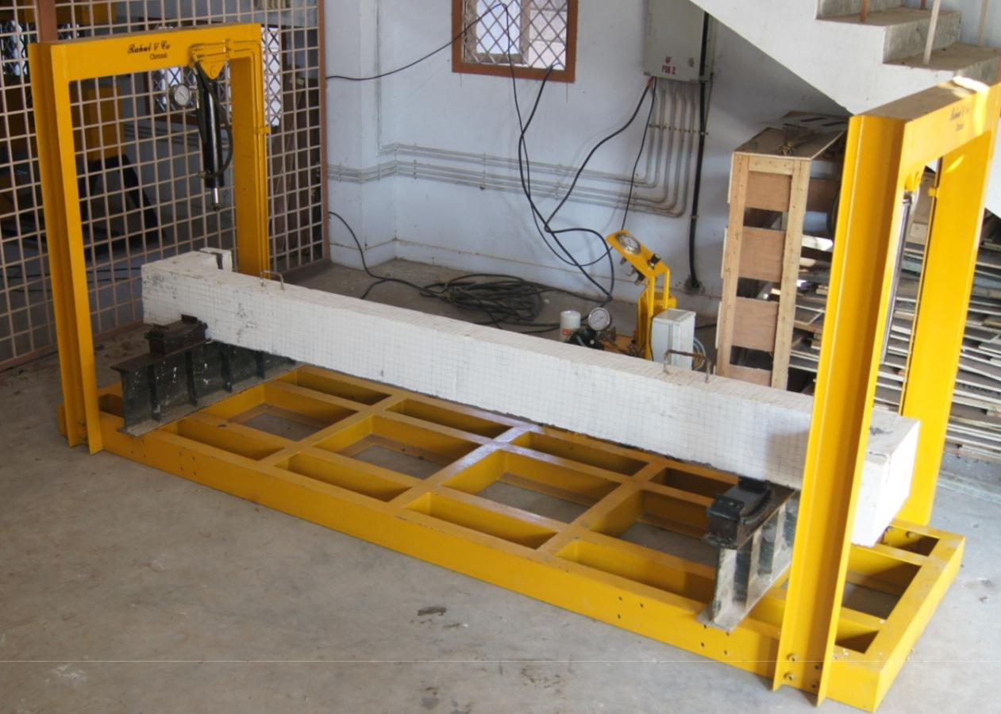

Fig. 3.10 Torsion Testing Equipment

Fig. 5.1 Stress-strain Curve of Concrete in Flexural Compression
ANNEXURE 13

LIST OF PAPERS SUBMITTED BASED ON THIS THESIS

PAPERS PUBLISHED IN NATIONAL JOURNALS

- Prakhya, G.K.V. (2001), Tension Stiffening and Moment - Curvature Relations of
Reinforced Concrete Elements, Journal of Structural Engineering, Vol. 87(3), Sept.–Oct., pp. 597–602.

PAPERS PUBLISHED IN INTERNATIONAL JOURNALS

- Prakhya, G.K.V. (2002a), Ductile Beam column connections for Prestressed Concrete
Elements, Journal of Structural Engineering, Vol. 87(5), Sept.–Oct., pp. 597–602.

- Prakhya, G.K.V. (2002b), Tension Stiffening and Moment-Curvature Relations of
Reinforced Concrete Elements, Journal of Structural Engineering, Vol.87, pp 597– 602.

PAPER PRESENTED IN CONFERENCES

- Bakis,C.E., Freimanis,.J., Gremel,D. and Nanni,A (1998), Effect of Resin Material on
Bond and Tensile Properties of Unconditioned and Conditioned FRP Reinforced Rods, Proceedings of 1st International conference on durability of Fibre Reinforced Polymer (FRP) Composites for Construction, Sherbrooke, August, 525-535.
ANNEXURE 14

A STUDY OF COMBINED BENDING AND AXIAL LOAD IN CONCRETE COLUMNS REINFORCED INTERNALLY WITH NON-METALLIC REINFORCEMENTS

< 14 pt; Times New Roman; no space in between lines; Bold>

< 2 line spaces each 12Pts >

  - SYNOPSIS

- 12 pt; Times New Roman; Bold>

<1 line space 12Pts >
Submitted by

< 12 pt; Times New Roman>

<1 line space 12Pts >
A.AJITHKUMAR

Roll Number 1331050017

< 14 pt; Times New Roman, Bold>

<2 line spaces each 12Pts >

In partial fulfilment for the requirements of the award of the degree of

< 12 pt; Times New Roman; italics>

DOCTOR OF PHILOSOPHY
IN

STRUCTURAL ENGINEERING

< 14 pt; Times New Roman; Bold>


< 4 line spaces each 12Pts >


< 3.5 cm ×3.5 cm Image >

DEPARTMENT OF CIVIL AND STRUCTURAL ENGINEERING

FACULTY OF ENGINEERING AND TECHNOLOGY
ANNAMALAI UNIVERSITY
ANNAMALAINAGAR - 608 002
TAMIL NADU, INDIA
MAY 2016

< 14 pt; Times New Roman; no space in between lines; Bold>

Ph.D. SYNOPSIS
PREPARATION AND SUBMISSION
GUIDELINES



FACULTY OF ENGINEERING & TECHNOLOGY
ANNAMALAI UNIVERSITY
ANNAMALAINAGAR – 608 002
April, 2016

Ph.D. SYNOPSIS GUIDELINES FOR
FACULTY OF ENGINEERING AND TECHNOLOGY

1. GENERAL
The synopsis is to be considered as a detailed summary of the work with important results highlighting the original contributions in the thesis to be submitted. It should give an outline of the thesis. The review of earlier work is to be minimized with just enough to highlight the contributions in the research work to be reported in the thesis. It is expected that at the time of submission of the synopsis no work is yet to be completed except writing the thesis and all other academic requirements such as course work, comprehensive examinations and the suggestions and directions given by members of the Doctoral Committee have been fulfilled. Ph.D. synopsis format is designed to provide Ph.D. scholar with the formatting requirements. The cover structure, layout, form, and style are given in Ph.D. Thesis guidelines. Total number of pages restricted to 20 including cover page.
2. SIZE OF SYNOPSIS
The size of synopsis should be 20 pages of 1.5 spacing on A4 size good quality white paper preferably not lower than 80 gsm.
3. LAY OUT OF SYNOPSIS
i. Cover Page (Refer ANNEXURE 13)
ii. Table of Contents
iii. Body of the Synopsis
Motivation and Problem statement
Brief survey of earlier work
Overview of the thesis
Major contributions (if required with results/ graphs/photographs)
Conclusions
iv. List of References (pointed references only in the body of the synopsis)
v. List of Publications (from the Ph.D. work)
4. TYPING INSTRUCTIONS
Similar to Ph.D. guidelines
5. BINDING SPECIFICATIONS
Copies of the synopsis should be sewn and bound using flexible cover of thick white art paper. The cover should be printed in black letters and the text for printing should be identical to what has been prescribed for Ph.D. cover page.

